Ideation Phase

Define the Problem Statements

|  |  |
| --- | --- |
| Date | 8 JUNE 2025 |
| Team ID | LTVIP2025TMID59169 |
| Project Name | Citizen AI – Intelligent Citizen Engagement Platform |
| Maximum Marks | 2 Marks |

**Customer Problem Statement Template:**

Create a problem statement to understand your customer's point of view. The Customer Problem Statement template helps you focus on what matters to create experiences people will love.

A well-articulated customer problem statement allows you and your team to find the ideal solution for the challenges your customers face. Throughout the process, you’ll also be able to empathize with your customers, which helps you better understand how they perceive your product or service.

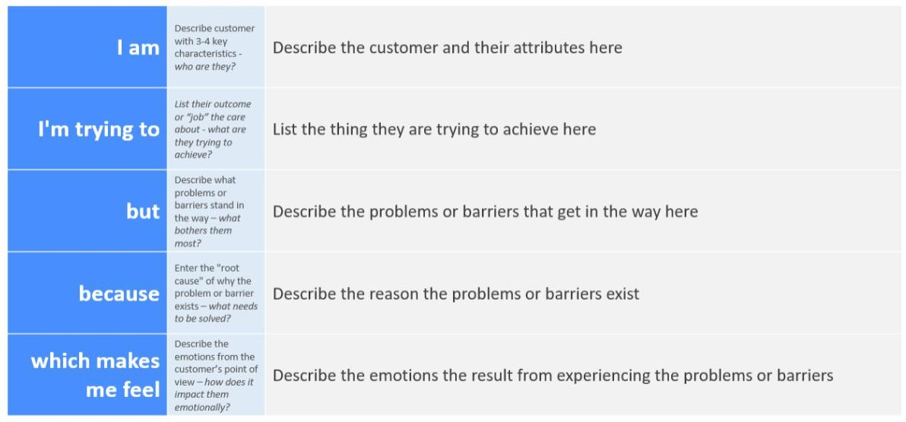

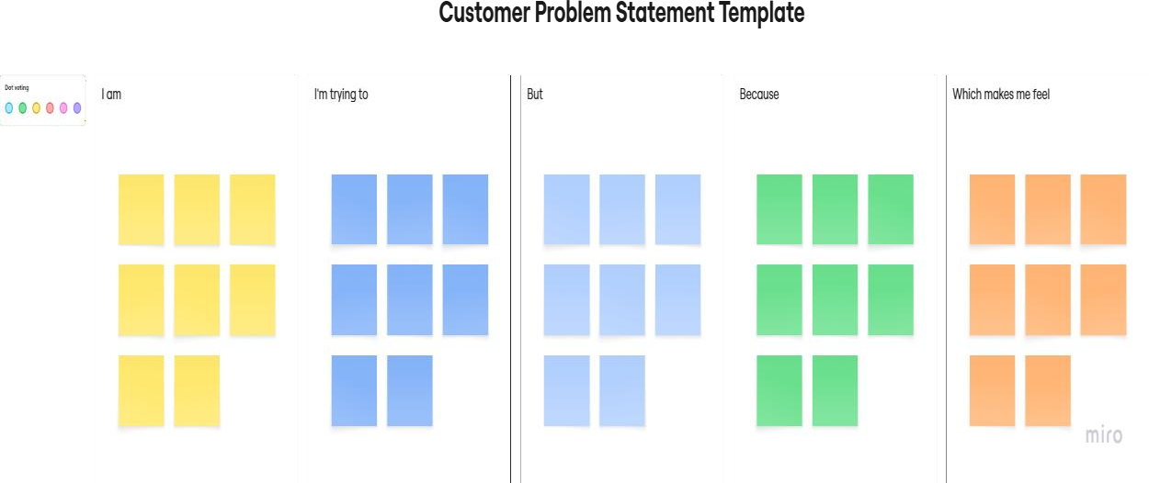

|  |  |  |  |  |  |
| --- | --- | --- | --- | --- | --- |
| **Problem**  **Statement (PS)** | **I am (Customer)** | **I’m trying**  **to** | **But** | **Because** | **Which**  **makes me feel** |
| PS-1 | A citizen who needs help with government- related queries and services | Find accurate, fast, and helpful information from government portals | Government websites are often confusing, outdated, or hard to navigate | There is no centralized and conversational platform for help | Frustrated, helpless, and sometimes avoid seeking help altogether |
| PS-2 | A common person with basic health- related questions | Get quick health tips or advice without always visiting a  hospital | I don’t have easy access to medical professionals or verified sources | Rural areas and low-income communities lack infrastructure and awareness | Worried, ignored, and unsure about my health decisions |